SQL CAPSTONE PROJECT

OBJECTIVE: The major aim of this project is to gain insight into the sales data of Amazon to understand the different factors that affect sales of the different branches.

ABOUT DATA: This dataset contains sales transactions from three different branches of Amazon, respectively located in Mandalay, Yangon and Naypyitaw. The data contains 17 columns and 1000 rows:

Created a database:

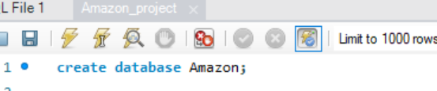

Creating Table:

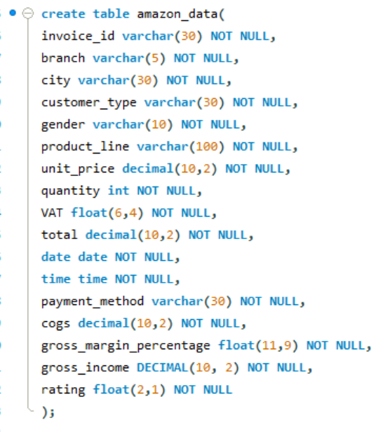

Loaded the data into the table:

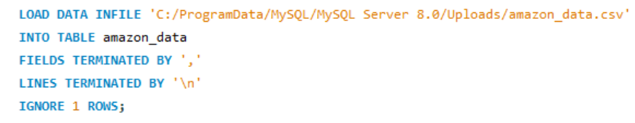

Table output:

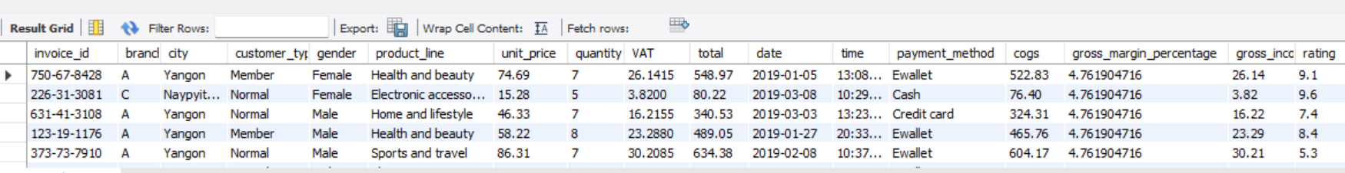

Data cleaning

* Dropped two columns.



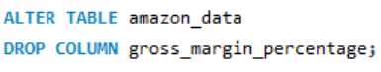

Feature engineering:

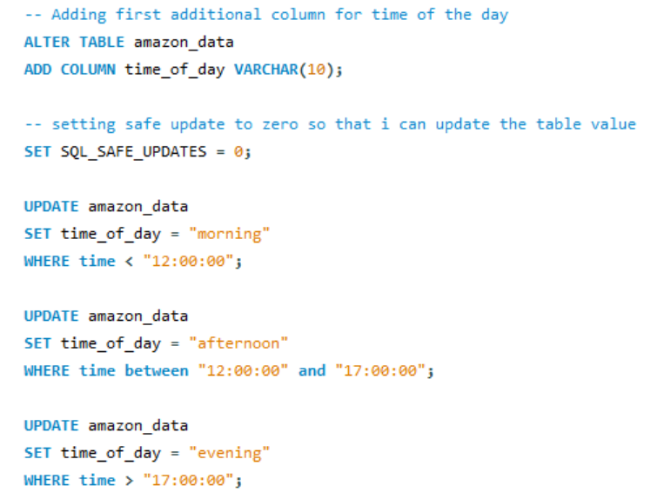

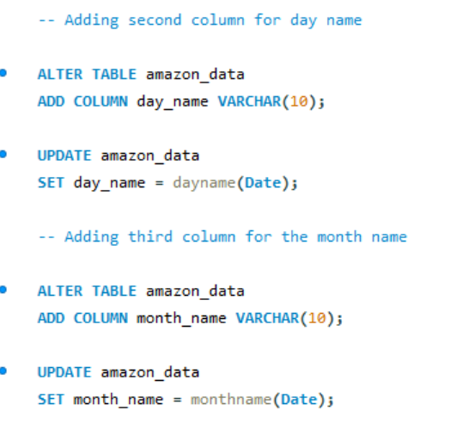

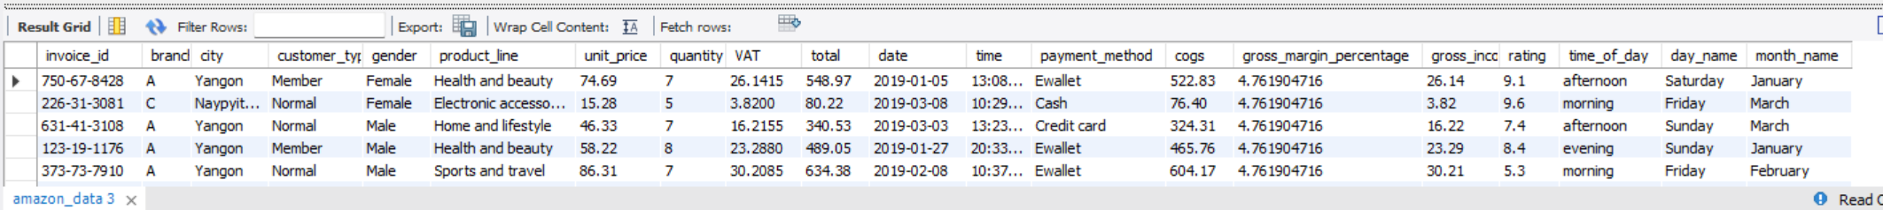

PRODUCT ANALYSIS:

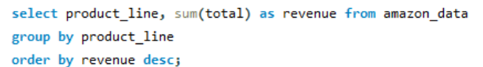

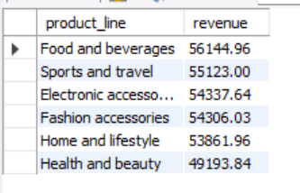

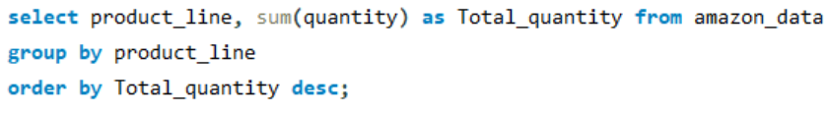

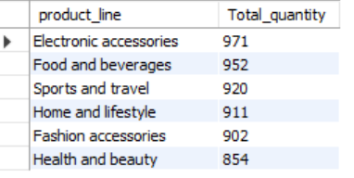

Customer Analysis

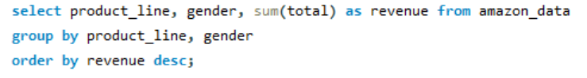

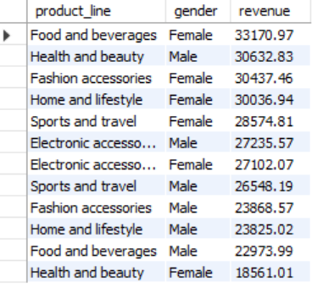

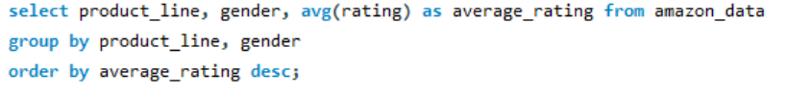

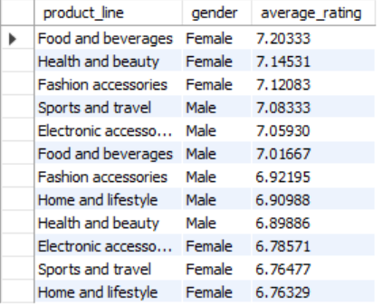

QUESTIONS:

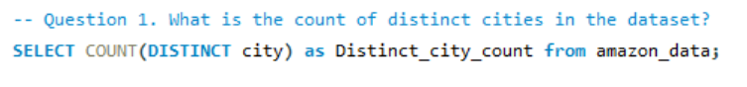

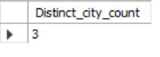

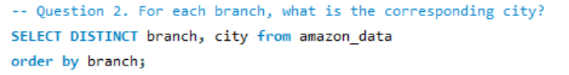

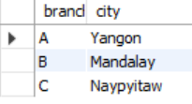



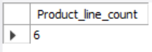

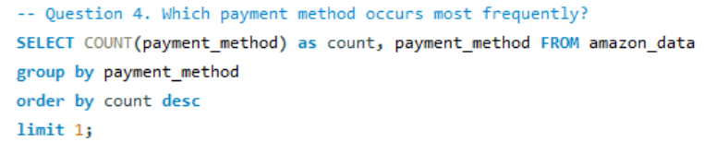

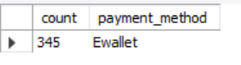

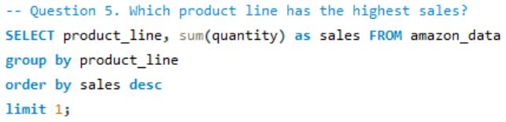

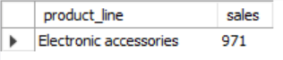

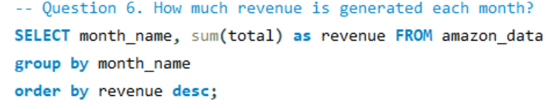

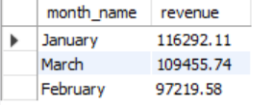

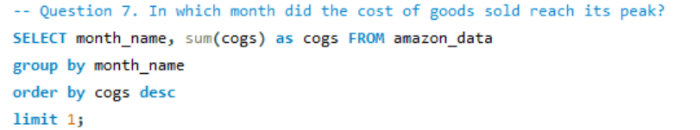

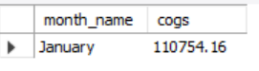

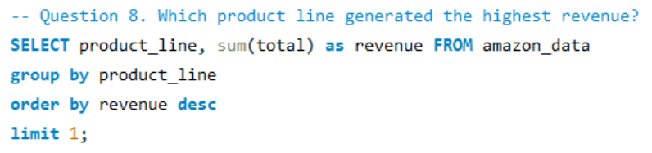

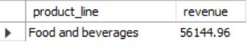

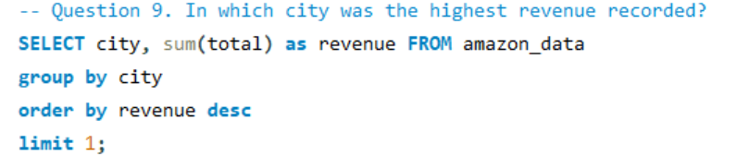



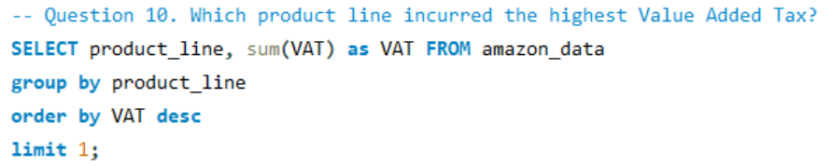

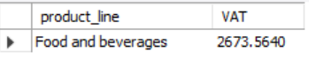

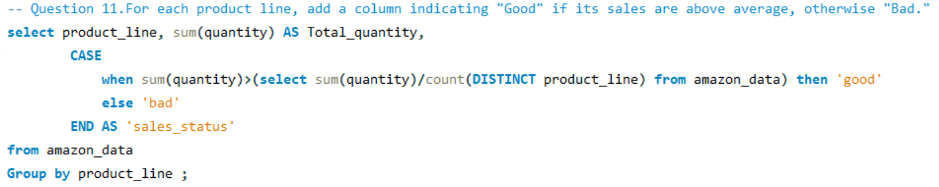

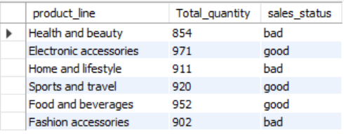

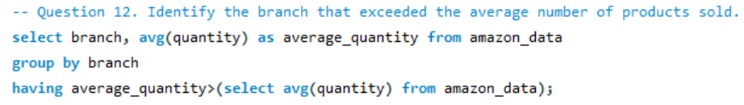



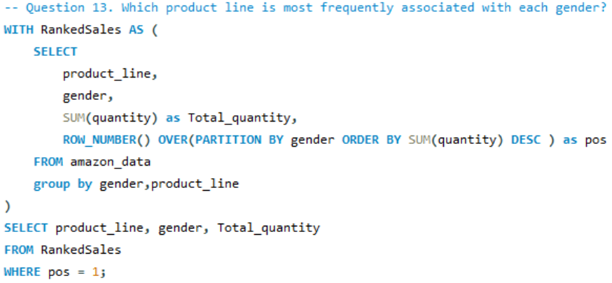

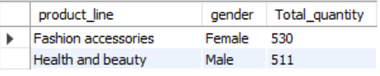

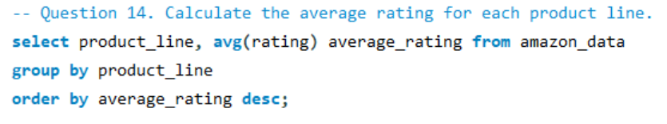

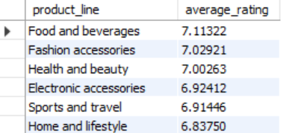

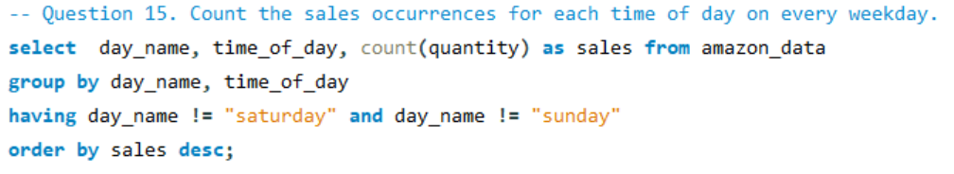

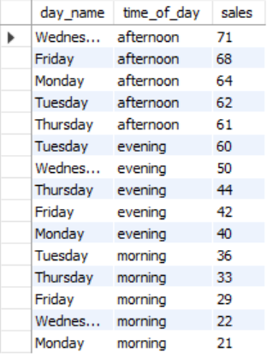

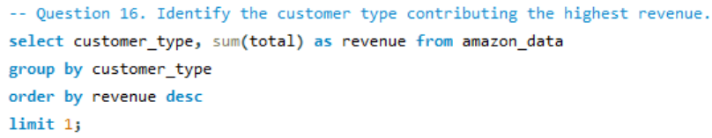



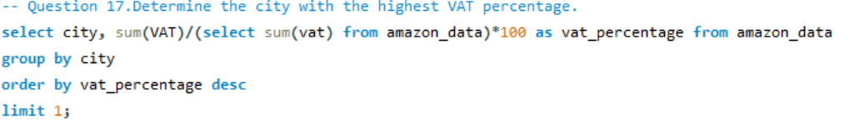

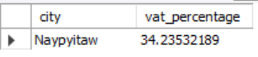

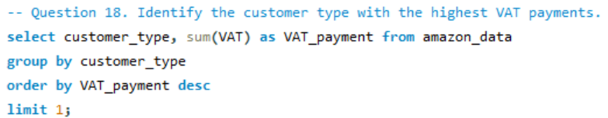







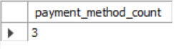

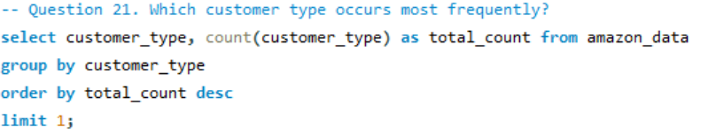

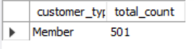

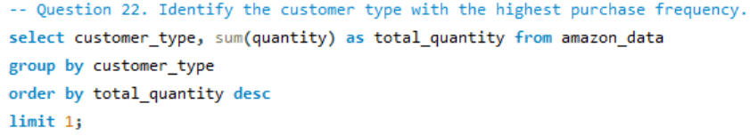

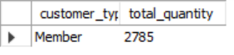

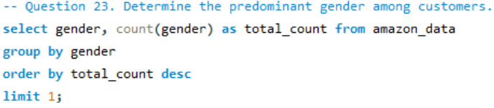



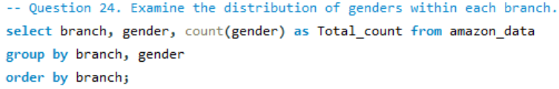

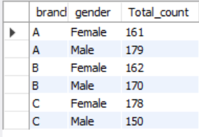

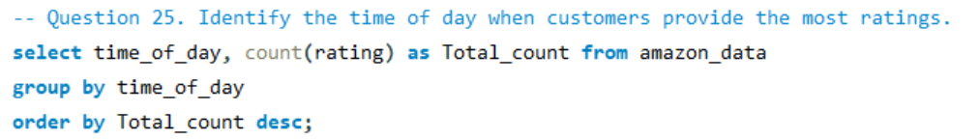

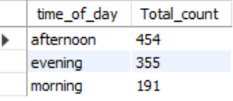

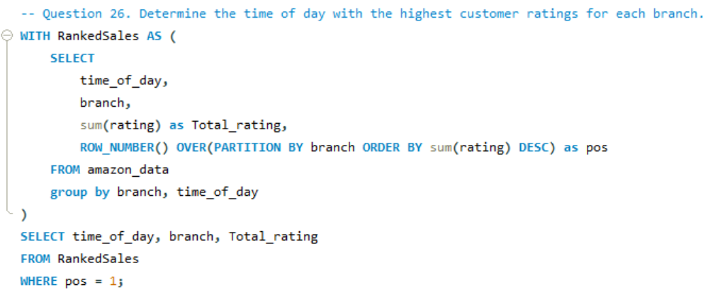

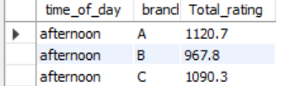

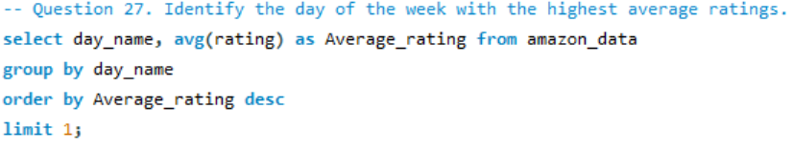

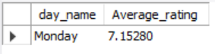

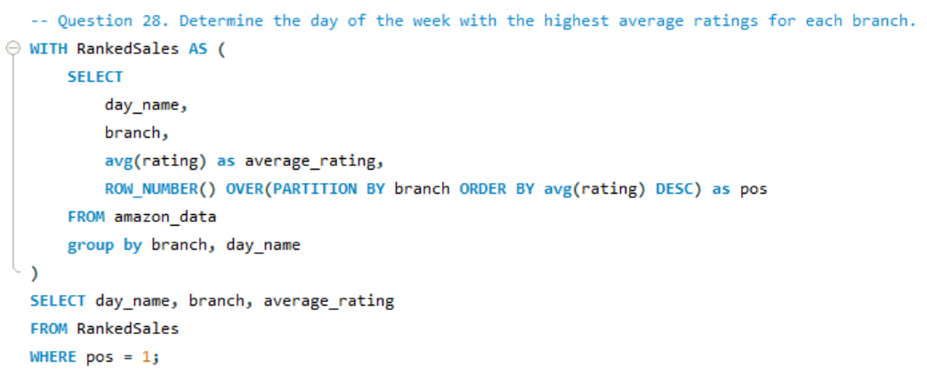

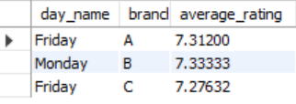

Insights and proposals:

* From the customer types, the members are generating more revenue than the normal customers. So, we can give membership points which the customers can redeem so as to convert the non-members into members.
* We can see that the ratings provided for some product lines are really less. So, we can introduce a Survey to understand what each category is lacking.
* We can see that food and beverages is generating the most revenue and health beauty is doing the least. So maybe we can do a Brand Performance Analysis is like which brands are currently doing well in the market and suggest those brands in the different branches.